The Good News

April Volume 4 / Issue 7
April is . . .
Walking Day (April 3), Fresh Tomato Day (April 6), Empanada Day (April 8), Grilled Cheese Sandwich Day (April 12), Day of the Mushroom (April 16), Garlic Day (April 19),
Easter (April 21, 2019), Earth Day (April 22), Picnic Day (April 23), Zucchini Bread Day (April 25), Prime Rib Day (April 27), Raisin Day (April 30)

Public Health Week (1st week in April)
Garden Week (2nd week in April)
Egg Salad Week (April 22-28, 2019 - the full week right after Easter Sunday) *

Cancer Control Month, Celery Month, Garden Month, Pecan Month, Soyfoods Month, Stress Awareness Month

https://food.unl.edu/april-food-calendar

March Claim - April 26, April Claim - May 31, May Claim - June 20, June Claim - July 26, July Claim - August 30, August Claim - September 23, September Claim - October 31, October Claim - November 26, November Claim - December 27.

Salina - 4/4/2019 - Martinelli's Little Italy -158 Sante Fe Ave, 6:30-8:30
Junction City - 4/9/2019 - Dorothy Bramlage Library, 6:30-8:30
Wamego - 4/16/19 - Senior Citizen Building, 6:30-8:30
Manhattan - 4/27/19 - Manhattan Public Library - 9:30-11:30
Concordia - 5/7/19 - CCCC Room 257, 6:30-8:30

Kansas Team Nutrition Sub-grants and Resources

Kansas Local Food & Gardening Sub-Grants for Child Care Centers and Daycare Home Providers
Child care centers and day care home providers have the opportunity to receive the USDA Grow It, Try It, Like It! gardening curriculum, the Kansas Farm Bureau Kailey’s Ag Adventure book series and sub-grant funds to implement nutrition education activities for children in their care! As part of a Team Nutrition Training Grant, KSDE CNW will award sub-grants to centers ($500 each) and to home providers ($200 each) along with program materials to implement a Local Kansas Food and Gardening nutrition education curriculum this spring. Applications will be available after March 15, 2019. For questions or additional information, contact Linnie Rieger at lrieger@ksde.org or call (785) 296-2276.
Applications due April 5, 2019

Healthier CACFP Award
$200 Sub-grants available - Contact Emily Brinkman, ebrinkman@ksde.org

Instant Oatmeal is creditable and it is a whole grain; however not all flavors of instant oatmeal will meet the sugar restrictions. I found that my favorite apples and cinnamon doesn't meet the requirement. I tried the peanut butter honey and it meets the sugar limit requirement and it was OK. My 3 yr old granddaughter ate it so, I guess it will work. I will be trying a peanut butter banana one that does meet the requirement the next time I buy instant oatmeal.

Providers have been able to find whole grain cinnamon toast sticks, so be on the look-out for those.
Providers have also found Scooby doo snacks and whole grain cinnamon goldfish crackers that are whole grain!
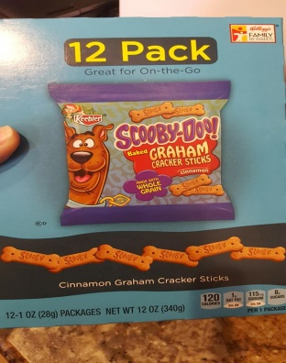
If you are not sure that a product will count as whole grain, then take a picture and send it to me.

Provider provided the picture for demonstration purposes, JCFHA doesn’t endorse products.

Squirrel Snacks
Ingredients:
Pita, whole wheat 4”
Avocado, sliced
Lettuce, shredded
Tomato, chopped
Carrots, grated
Turkey breast, lean, white meat
Honey mustard

Directions:
- Cut each pita open
- Spread 1tsp honey mustard in each pita
- Combine turkey and vegetables together in large bowl
- Place ½ cup mixture in each pita (can add more if needed)
- Top each with 1 slice avocado

CACFP Crediting for 3-5 yr olds; Lunch/Supper: Grains, Vegetable, and Meat.
Please list the items on your menu not just “squirrel snacks”

Serving it Safe
Prevent Cross-Contamination
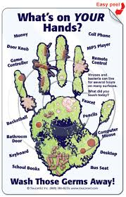
One of the most common causes of food-borne illness is cross-contamination, the transfer of bacteria from
- Hand to food
- Food to food
- Equipment to food

Microorganisms live throughout the kitchen and can easily move around by attaching themselves to people, food, and equipment. Cross-contamination can occur anywhere in a food-service operation but can be prevented by physical barriers or by food safety procedures.

Contact Us

JC Family Home Association
PO Box 1203 Junction City, KS 66441
785-762-2424 / Fax: 785-762-2623
Janet@jcfha.kscoxmail.com
JC Family Home Association

Director: Janet Dozier
Assistant Director: Vanda Taylor
Consultant: Christine Moravec
Consultant: Barbara Gabriel

USDA Nondiscrimination Statement
In accordance with Federal civil rights law and U.S. Department of Agriculture (USDA) civil rights regulations and policies, the USDA, its Agencies, offices, and employees, and institutions participating in or administering USDA programs are prohibited from discriminating based on race, color, national origin, sex, disability, age, or reprisal or retaliation for prior civil rights activity in any program or activity conducted or funded by USDA.
Persons with disabilities who require alternative means of communication for program information (e.g. Braille, large print, audiotape, American Sign Language, etc.), should contact the Agency (State or local) where they applied for benefits. Individuals who are deaf, hard of hearing or have speech disabilities may contact USDA through the Federal Relay Service at (800) 877-8339. Additionally, program information may be made available in languages other than English.
To file a program complaint of discrimination, complete the USDA program discrimination complaint form, (AD-3027) found online at https://www.ascr.usda.gov/sites/default/files/Complain_combined_6_8_12_508_0.pdf and at any USDA office, or write a letter addressed to USDA and provide in the letter all of the information requested in the form. To request a copy of the complaint form, call (866) 632-0002. Submit your completed form or letter to USDA by:

Mail: U.S. Department of Agriculture
Office of the Assistant Secretary for Civil Rights
1400 Independence Avenue, SW
Washington, D.C. 20250-9410
Fax: (202) 690-7442; or
Email: program.intake@usda.gov.

